
Symbiosis Institute of Technology, Pune
CSE- Academic Year 2026-27
Java Programming – Lab Batch 2025-29
Lab Assignment No.: 8
Name of Student | Akshit Gawade
PRN No. | 25070122029
Batch | 2025-2029
Class | A1
Academic Year & Semester | Second Year  Semester III
Date of Submission | 11/7/2026
Title of Assignment: | Write a Java program to demonstrate the use of the super keyword in inheritance.
Problem Statement  Learning Objectives | Write a Java program to demonstrate the use of the super keyword in inheritance.  To demonstrate the use of the super keyword for accessing parent class members
Theory | The super keyword is used to refer to the immediate parent class in Java. It can invoke parent class constructors, access parent class variables, and call overridden methods. It ensures proper constructor chaining during object creation.
Program Code | 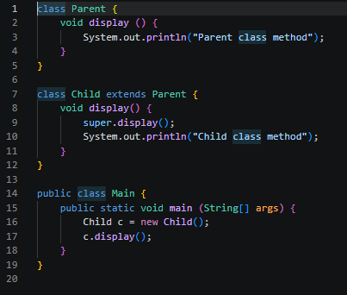
Output Screenshots | 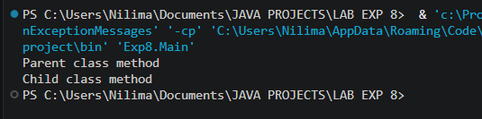
Exercise Qns | Q1. Create an Employee and Manager program where Manager accesses Employee details using super keyword.  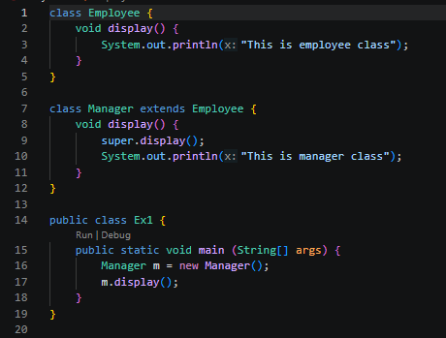  Q2. Develop a Vehicle Insurance System where child insurance classes access parent vehicle information using the super keyword.  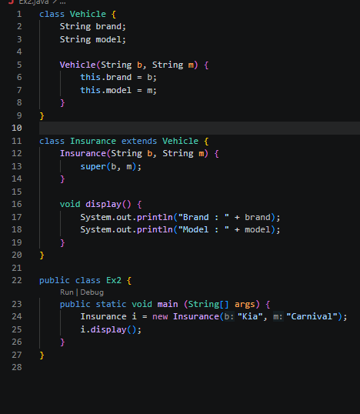
Output Screenshots | 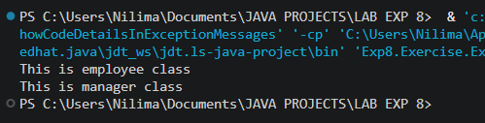  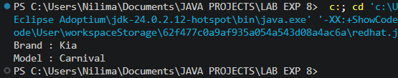
Conclusion | This assignment helped in understanding the use of the super keyword in Java inheritance. It demonstrated how the super keyword is used to access parent class constructors, variables, and methods from a child class, ensuring proper initialization and reducing code duplication. The implementation improved my understanding of inheritance, constructor chaining, and method overriding in object-oriented programming. These concepts are widely used in developing desktop applications, web applications, Android applications, enterprise software, and other real-world Java programs that require efficient code reuse, maintainability, and hierarchical class design.

